

Course Title: Structured Programming

Assignment Title: CGPA Profiling

Spring 2018

Submitted by

Name: Rakibul Alam

Roll: 181-16-285

Submitted to

Mohammad Azizur Rahman

Lecturer, DIU

*Dept. of CIS*

*Daffodil International University*

Contents

Task 1 3

2. Flowchart for CGPA calculation: 5

3. Flow char for the process of file create and write: 6

Task 2 7

Sample of Input and output Program: 7

Sample 1: 7

Sample 2: 8

Sample 3: 11

# Task 1

1. **I have declared student as structure data type and its member are:**

* std_name[50] - which data type is a character array or string since name may have multiple letters
* ,std_id[20] - which data type is a character array or string since id may have multiple digits, special characters.
* num_of_sub_completed - Integer data type since number of completed subjects must be a whole number
* sum_credit - Integer data type since summation of whole number must be a whole number
* sum_gpa - floating-point type since summation of fraction values may be fraction value.
* cgpa - floating-point type since calculation of fraction value may be a fraction value

1. **I have also declared subjects as structure data type in the student and its member are:**

* sub_name[50] - which data type is a character array or string since name may have multiple letters
* sub_credits - Integer data type since credit number must be a whole number
* sub_gpa - floating-point type since gpa may have fraction value

I have used above structures to store multiple data type values for student and subject’s information. **Here I have used structure as;**

* Nested Structure (subjects in student)
* Structure and function (Passing structure student via function)
* Array of Structure (Subjects structure to store multiple times for student, I used array of structure)

1. For counting num_of_sub_completed, I have used i as counter.
2. FILE is defined as data structure of file. I have declared file as FILE type - variable as a pointer. For storing data in the secondary memory in the file, FILE have been chosen. The file pointer contains all the information about file and also it works as communication link between the operating system and program.
3. I have used answer as a character data type to check is student add or not.

**Reasons for choosing float for decimal point numbers.**

For decimal point number, I have used floating-point data type rather than used double since double value storage size more than float point storage size. So, using floating point data type, use less memory at the time of program compile and running. Also, another reason for choosing floating-point data type, in the program use 2/3 places after decimal point use in the program

**Data structure (Array):**

As array can store collection of same type of data, I have used array as a data structure to store multiple subject’s values. It is easy to process and manipulate same time of large amount of data using array. A student can have many subjects that’s why subject information need to store multiple times for a student.

# 2. Flowchart for CGPA calculation:

**Figure: Flow chart for CGPA calculation**

## 3. Flow char for the process of file create and write:

**Figure: Flow chart for the process of file create and write**

# Task 2

## Sample of Input and output Program:

### Sample 1:

Input: One student who have two subjects

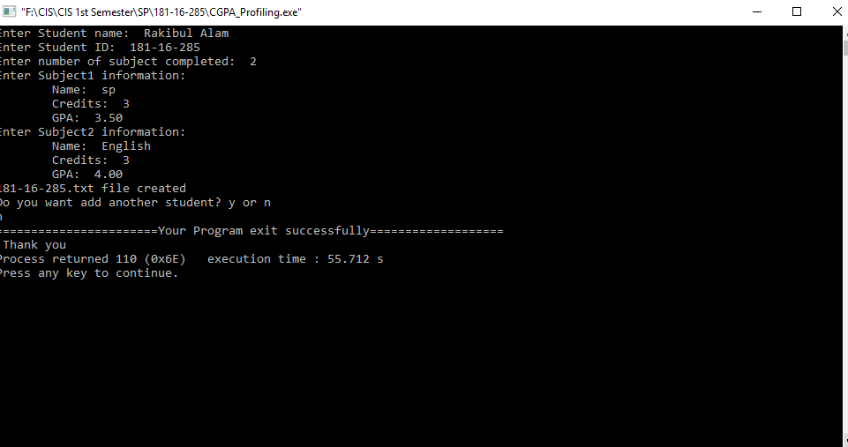

**Figure: Sample input 1**

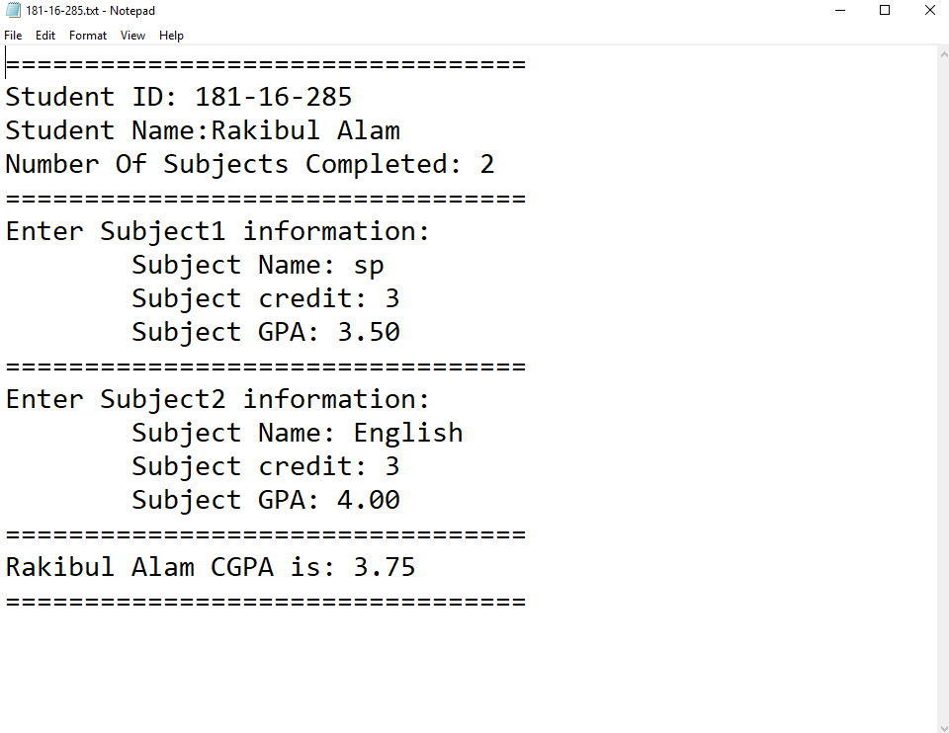

**Figure: Sample output 1**

### Sample 2:

Input: Two student: each have one subject

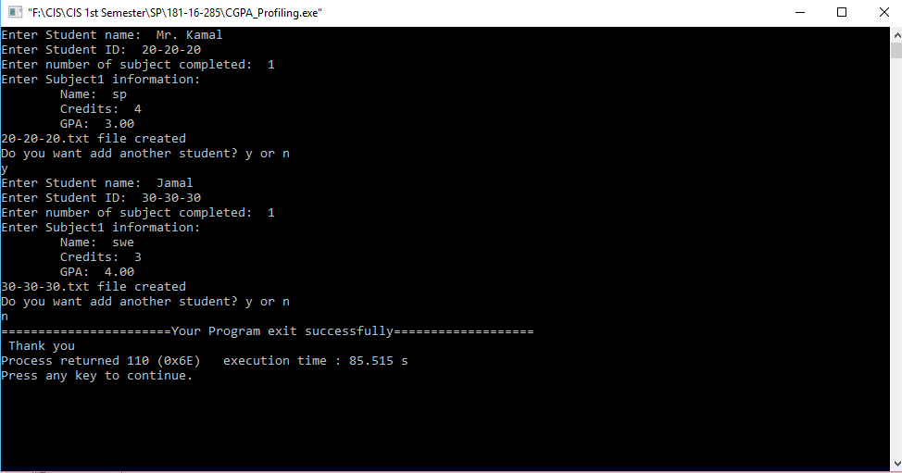

**Figure: Sample input 2**

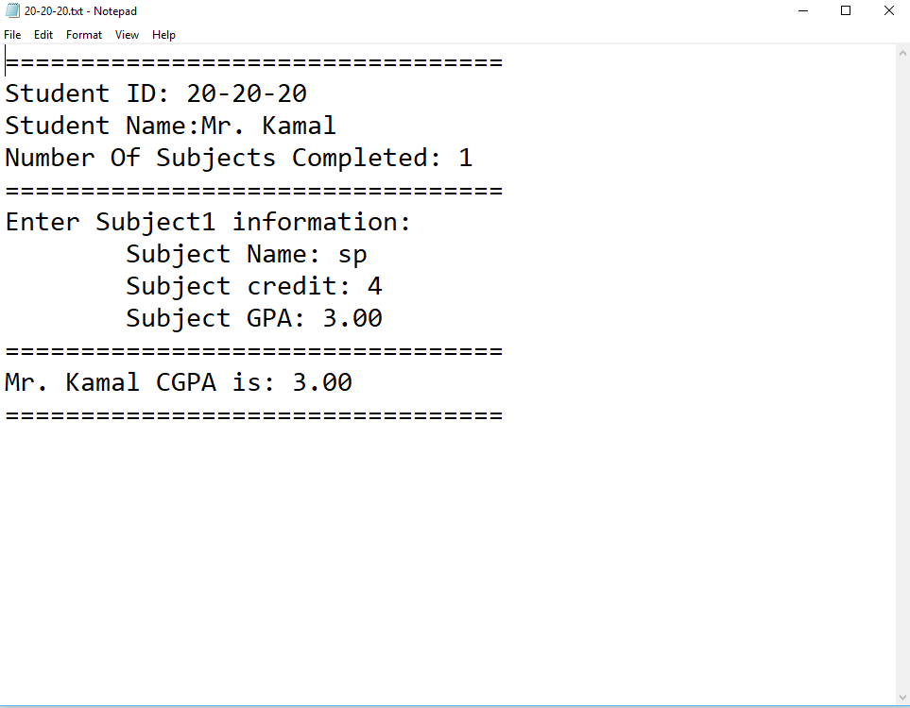

**Figure: Sample output 2.1**

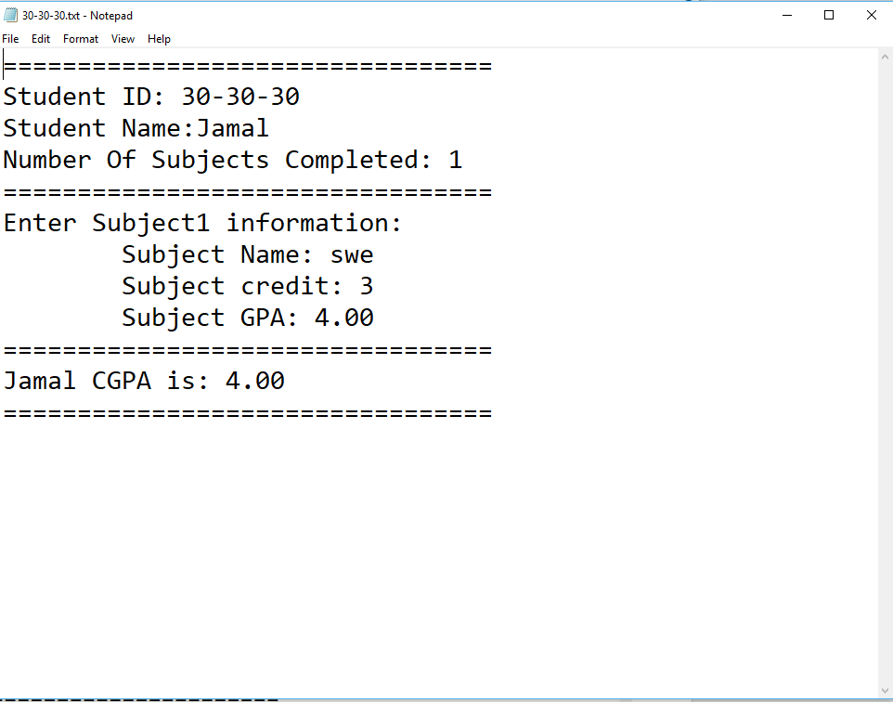

**Figure: Sample output 2.2**

### Sample 3:

Input: One student who have three subjects

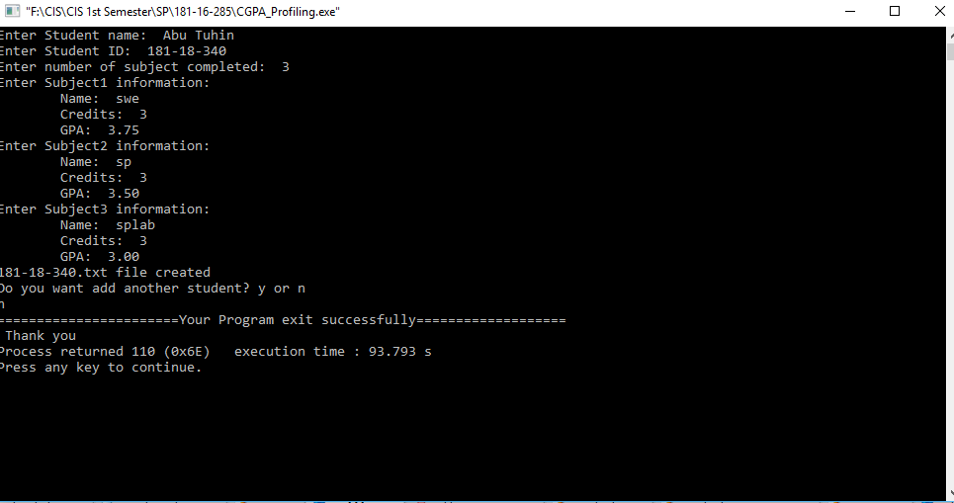

**Figure: Sample input 3**

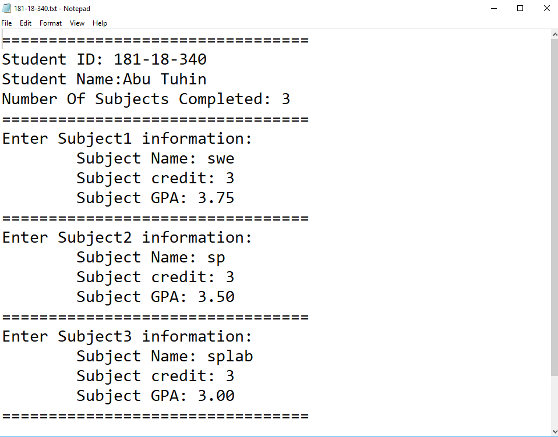

**Figure: Sample output 3**